## **GAUTAM BUDDHA UNIVERSITY**

## 

## **PYTHON PROGRAMMING PRACTICAL FILE**

## **LAB CODE**: **CS-385**

## 

## **PROGRAM: B.Tech CSE**

## **SEMESTER: 5**

## 

## **SUBMITTED TO**: MS. JYOTI KAURAV

## **SUBMITTED BY**: VARUN PRATAP SINGH (215/UCF/009)

## 

INDEX

|  |  |  |  |
| --- | --- | --- | --- |
| S.NO | EXPERIMENT | DATE | SIGN |
| 1. | WRITE A PROGRAM TO IMPLEMENT OPERATORS |  |  |
| 2. | WRITE A PROGRAM TO PRINT PATTERNS |  |  |
| 3. | WRITE A PROGRAM TO IMPLEMENT STRING OPERATIONS |  |  |
| 4. | WRITE A PROGRAM TO IMPLEMENT DIFFERENT WAY TO PRINT LIST |  |  |
| 5. | WRITE A PROGRAM TO IMPLEMENT STACK AND QUEUE |  |  |
| 6. | WRITE A PROGRAM TO IMPLEMENT DIFFERENT OPERATIONS IN DICTIONARY |  |  |
| 7. | WRITE A PROGRAM TO IMPLEMENT LAMBDA FUNCTION, MAP FUNCTION AND FILTER FUNCTION |  |  |
| 8. | WRITE A PROGRAM TO IMPLEMENT MULTIPLE INHERITANCE |  |  |
| 9. | WRITE A PROGRAM TO READ AND WRITE FILES |  |  |
| 10. | WRITE A PROGRAM FOR DATA ANALYSING BY IMPORTING FILES |  |  |
| 11. | WRITE A PROGRAM TO IMPLEMENT EXCEPTION HANDLING |  |  |

OBJECTIVE – PROGRAM TO IMPLEMENT OPERATORS

EXPERIMENT 1

# Arithmetic operators

x = 10

y = 5

addition = x + y

subtraction = x - y

multiplication = x * y

division = x / y

floor_division = x // y

modulus = x % y

exponentiation = x ** y

print(f"Arithmetic Operators:")

print(f"Addition: {addition}")

print(f"Subtraction: {subtraction}")

print(f"Multiplication: {multiplication}")

print(f"Division: {division}")

print(f"Floor Division: {floor_division}")

print(f"Modulus: {modulus}")

print(f"Exponentiation: {exponentiation}\n")

# Comparison operators

a = 10

b = 20

equal = a == b

not_equal = a != b

greater_than = a > b

less_than = a < b

greater_than_or_equal = a >= b

less_than_or_equal = a <= b

print(f"Comparison Operators:")

print(f"Equal: {equal}")

print(f"Not Equal: {not_equal}")

print(f"Greater Than: {greater_than}")

print(f"Less Than: {less_than}")

print(f"Greater Than or Equal: {greater_than_or_equal}")

print(f"Less Than or Equal: {less_than_or_equal}\n")

# Logical operators

p = True

q = False

logical_and = p and q

logical_or = p or q

logical_not = not p

print(f"Logical Operators:")

print(f"Logical AND: {logical_and}")

print(f"Logical OR: {logical_or}")

print(f"Logical NOT: {logical_not}\n")

# Assignment operators

z = 5

z += 3 # Equivalent to z = z + 3

print(f"Assignment Operator (+=): {z}\n")

# Membership operators

fruits = ['apple', 'banana', 'orange']

is_in = 'banana' in fruits

is_not_in = 'grape' not in fruits

print(f"Membership Operators:")

print(f"'banana' is in fruits: {is_in}")

print(f"'grape' is not in fruits: {is_not_in}")

OUTPUT:

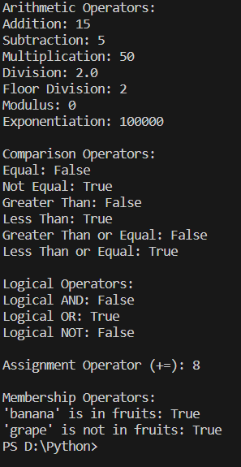

OBJECTIVE: WRITE A PROGRAM TO PRINT PATTERNS

EXPERIMENT 2

def print_square_pattern(n):

for i in range(n):

for j in range(n):

print("*", end=" ")

print()

def print_triangle_pattern(n):

for i in range(1, n + 1):

for j in range(i):

print("*", end=" ")

print()

def print_inverted_triangle_pattern(n):

for i in range(n, 0, -1):

for j in range(i):

print("*", end=" ")

print()

def print_pyramid_pattern(n):

for i in range(1, n + 1):

print(" " * (n - i) + "* " * i)

def main():

print("Square Pattern:")

print_square_pattern(5)

print("\nTriangle Pattern:")

print_triangle_pattern(5)

print("\nInverted Triangle Pattern:")

print_inverted_triangle_pattern(5)

print("\nPyramid Pattern:")

print_pyramid_pattern(5)

if __name__ == "__main__":

main()



EXPERIMENT 3

OBJECTIVE: WRITE A PROGRAM TO IMPLEMENT STRING OPERATIONS

def string_operations(input_string):

# Length of the string

length = len(input_string)

print(f"Length of the string: {length}")

# Concatenation

new_string = input_string + " Concatenated"

print(f"Concatenated string: {new_string}")

# String repetition

repeated_string = input_string * 3

print(f"String repetition: {repeated_string}")

# String slicing

substring = input_string[2:6]

print(f"Sliced substring (index 2 to 5): {substring}")

# String uppercase and lowercase

uppercase_string = input_string.upper()

lowercase_string = input_string.lower()

print(f"Uppercase string: {uppercase_string}")

print(f"Lowercase string: {lowercase_string}")

# String replace

replaced_string = input_string.replace('Python', 'Java')

print(f"String replace: {replaced_string}")

# String find

substring_index = input_string.find('is')

print(f"Index of 'is': {substring_index}")

# String count

substring_count = input_string.count('is')

print(f"Count of 'is': {substring_count}")

# String split

words = input_string.split(' ')

print(f"String split into words: {words}")

# String strip

stripped_string = " leading and trailing spaces "

stripped_result = stripped_string.strip()

print(f"Stripped result: '{stripped_result}'")

if __name__ == "__main__":

input_string = "Python is a powerful programming language."

print(f"Original String: {input_string}\n")

string_operations(input_string)

OUTPUT:

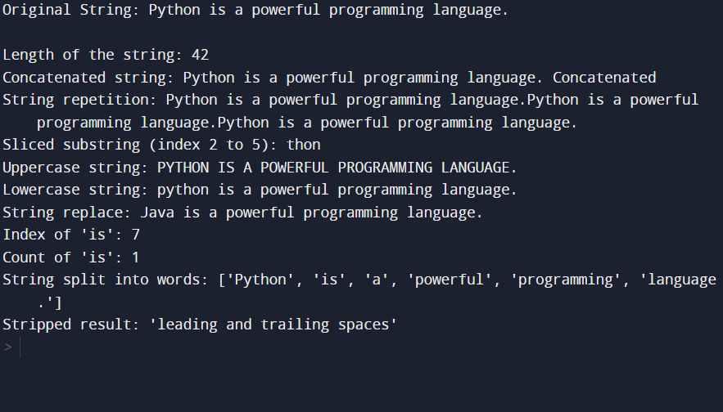

EXPERIMENT 4

OBJECTIVE: WRITE A PROGRAM TO IMPLEMENT DIFFERENT WAYS TO PRINT LIST.

def print_list_methods(my_list):

# Method 1: Using a simple loop

print("Method 1: Using a simple loop")

for item in my_list:

print(item, end=" ")

print("\n")

# Method 2: Using list comprehension

print("Method 2: Using list comprehension")

print(" ".join([str(item) for item in my_list]))

print()

# Method 3: Using map and join

print("Method 3: Using map and join")

print(" ".join(map(str, my_list)))

print()

# Method 4: Using * unpacking

print("Method 4: Using * unpacking")

print(*my_list)

print()

# Method 5: Using the pprint module

import pprint

print("Method 5: Using the pprint module")

pprint.pprint(my_list)

print()

# Method 6: Using the print function with sep parameter

print("Method 6: Using the print function with sep parameter")

print(*my_list, sep=" ")

print()

if __name__ == "__main__":

my_list = [1, 2, 3, 4, 5]

print(f"Original List: {my_list}\n")

print_list_methods(my_list)

OUTPUT:

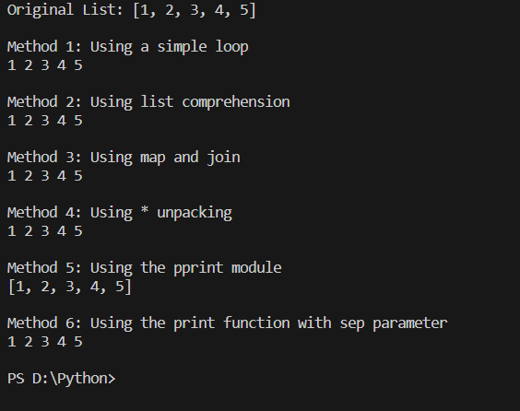

EXPERIMENT 5

OBJECTIVE: WRITE A PROGRAM STACK AND QUEUE

class Stack:

def __init__(self):

self.items = []

def is_empty(self):

return len(self.items) == 0

def push(self, item):

self.items.append(item)

def pop(self):

if not self.is_empty():

return self.items.pop()

else:

print("Stack is empty")

def peek(self):

if not self.is_empty():

return self.items[-1]

else:

print("Stack is empty")

def size(self):

return len(self.items)

class Queue:

def __init__(self):

self.items = []

def is_empty(self):

return len(self.items) == 0

def enqueue(self, item):

self.items.append(item)

def dequeue(self):

if not self.is_empty():

return self.items.pop(0)

else:

print("Queue is empty")

def peek(self):

if not self.is_empty():

return self.items[0]

else:

print("Queue is empty")

def size(self):

return len(self.items)

# Example usage:

stack = Stack()

stack.push(1)

stack.push(2)

stack.push(3)

print("Stack:", stack.items)

print("Pop:", stack.pop())

print("Peek:", stack.peek())

print("Size:", stack.size())

queue = Queue()

queue.enqueue('a')

queue.enqueue('b')

queue.enqueue('c')

print("\nQueue:", queue.items)

print("Dequeue:", queue.dequeue())

print("Peek:", queue.peek())

print("Size:", queue.size())

OUTPUT:

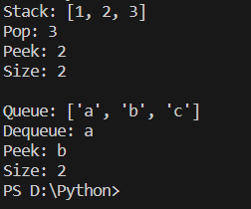

EXPERIMENT 6

OBJECTIVE: WRITE A PROGRAM TO IMPLEMENT OPERATIONS IN DICTIONARY

def dictionary_methods(my_dict):

# Method 1: Accessing elements by key

print("Method 1: Accessing elements by key")

key = 'name'

value = my_dict[key]

print(f"The value for key '{key}': {value}\n")

# Method 2: Adding a new key-value pair

print("Method 2: Adding a new key-value pair")

new_key = 'age'

new_value = 25

my_dict[new_key] = new_value

print(f"Updated dictionary: {my_dict}\n")

# Method 3: Removing a key-value pair using pop

print("Method 3: Removing a key-value pair using pop")

removed_value = my_dict.pop('age')

print(f"Removed key-value pair: {removed_value}")

print(f"Updated dictionary: {my_dict}\n")

# Method 4: Getting a value with a default

print("Method 4: Getting a value with a default")

default_value = my_dict.get('country', 'Not available')

print(f"Value for key 'country': {default_value}\n")

# Method 5: Iterating through keys

print("Method 5: Iterating through keys")

for key in my_dict.keys():

print(key, end=" ")

print("\n")

# Method 6: Iterating through values

print("Method 6: Iterating through values")

for value in my_dict.values():

print(value, end=" ")

print("\n")

# Method 7: Iterating through key-value pairs

print("Method 7: Iterating through key-value pairs")

for key, value in my_dict.items():

print(f"{key}: {value}")

print("\n")

# Method 8: Clearing the dictionary

print("Method 8: Clearing the dictionary")

my_dict.clear()

print(f"Cleared dictionary: {my_dict}\n")

if __name__ == "__main__":

my_dict = {'name': 'John', 'city': 'New York', 'occupation': 'Engineer'}

print(f"Original Dictionary: {my_dict}\n")

dictionary_methods(my_dict)

OUTPUT:

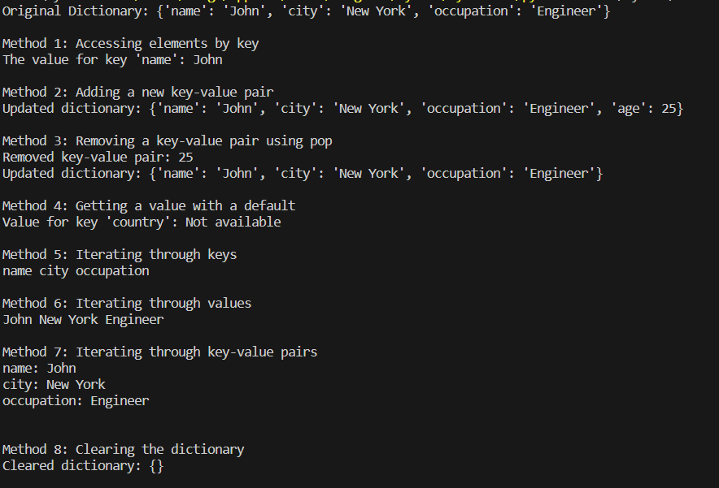

OBJECTIVE: WRITE A PROGRAM TO IMPLEMENT LAMBDA, MAP AND FILTER FUNCTION

EXPERIMENT 7

# Example 1: Lambda function

square = lambda x: x ** 2

cube = lambda x: x ** 3

print("Example 1: Lambda function")

print("Square of 5:", square(5))

print("Cube of 3:", cube(3))

print()

# Example 2: Map function

numbers = [1, 2, 3, 4, 5]

squared_numbers = list(map(lambda x: x ** 2, numbers))

cubed_numbers = list(map(lambda x: x ** 3, numbers))

print("Example 2: Map function")

print("Original numbers:", numbers)

print("Squared numbers:", squared_numbers)

print("Cubed numbers:", cubed_numbers)

print()

# Example 3: Filter function

even_numbers = list(filter(lambda x: x % 2 == 0, numbers))

odd_numbers = list(filter(lambda x: x % 2 != 0, numbers))

print("Example 3: Filter function")

print("Original numbers:", numbers)

print("Even numbers:", even_numbers)

print("Odd numbers:", odd_numbers)

OUTPUT:

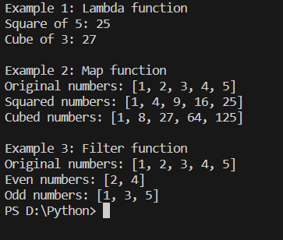

OBJECTIVE: WRITE A PROGRAM TO IMPLEMENT MULTIPLE INHERITANCE

EXPERIMENT 8

# Parent class 1

class Animal:

def __init__(self, name):

self.name = name

def make_sound(self):

pass # Placeholder method

# Parent class 2

class Flyable:

def fly(self):

print(f"{self.name} is flying.")

# Parent class 3

class Swimmable:

def swim(self):

print(f"{self.name} is swimming.")

# Child class inheriting from Animal and Flyable

class Bird(Animal, Flyable):

def make_sound(self):

print(f"{self.name} is chirping.")

# Child class inheriting from Animal and Swimmable

class Fish(Animal, Swimmable):

def make_sound(self):

print(f"{self.name} is bubbling.")

if __name__ == "__main__":

# Example usage

bird = Bird("Sparrow")

bird.make_sound()

bird.fly()

print()

fish = Fish("Goldfish")

fish.make_sound()

fish.swim()

OUTPUT:

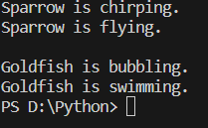

OBJECTIVE: WRITE A PROGRAM TO READ AND WRITE FILES

EXPERIMENT 9

# Writing to a file

def write_to_file(file_name, content):

with open(file_name, 'w') as file:

file.write(content)

print(f"Content written to {file_name}\n")

# Reading from a file

def read_from_file(file_name):

try:

with open(file_name, 'r') as file:

content = file.read()

print(f"Content read from {file_name}:\n{content}")

except FileNotFoundError:

print(f"File {file_name} not found.")

except Exception as e:

print(f"An error occurred: {e}")

if __name__ == "__main__":

file_name = "sample_file.txt"

content_to_write = "Hello, this is a sample file content.\nPython is awesome!"

# Writing to a file

write_to_file(file_name, content_to_write)

# Reading from a file

read_from_file(file_name)

OUTPUT:

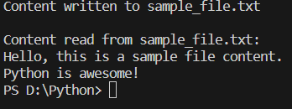

EXPERIMENT 10

OBJECTIVE: WRITE A PROGRAM FOR DATA ANALYSING BY IMPORTING FILES

import pandas as pd

def analyze_data(file_path):

# Read data from a CSV file into a Pandas DataFrame

try:

df = pd.read_csv(file_path)

# Display basic information about the DataFrame

print("Data Overview:")

print(df.info())

# Display descriptive statistics

print("\nDescriptive Statistics:")

print(df.describe())

# Display the first few rows of the DataFrame

print("\nFirst Few Rows:")

print(df.head())

# Perform additional data analysis as needed

except FileNotFoundError:

print(f"File {file_path} not found.")

except Exception as e:

print(f"An error occurred: {e}")

if __name__ == "__main__":

# Specify the path to your CSV file

csv_file_path = "sample_data.csv"

OBJECTIVE – WRITE A PROGRAM FOR EXCEPTION HANDLING

EXPERIMENT 11

def divide_numbers(a, b):

try:

result = a / b

except ZeroDivisionError:

print("Error: Cannot divide by zero.")

result = None

except TypeError as e:

print(f"Error: {e}")

result = None

else:

print(f"Result of {a} / {b}: {result}")

finally:

print("This block always executes.")

if __name__ == "__main__":

# Example 1: Division by zero

divide_numbers(5, 0)

# Example 2: Correct division

divide_numbers(10, 2)

# Example 3: TypeError

divide_numbers("10", 2)

# Analyze the data

analyze_data(csv_file_path)

OUTPUT:

